UK-ICN Annual General Meeting

Wednesday 2nd November 2022
Evening Dinner and Poster Session, Robinson College, Cambridge, UK

(Booking is essential - registration link at bottom of page)

Arrival and Drinks Reception: 17:00 - 18:00
Networking dinner: 18:00 – 20:00

Thursday 3rd November 2022
Annual General Meeting, Hilton City Centre, Cambridge, UK

Arrival and Registration: 08:15 – 09:00
Meeting Starts: 09:00
Meeting Ends: 17:00

The morning session will consist of keynote speakers and ECR flash talks that align with the UK-ICN research themes:
One Health and zoonoses, Surveillance; detection and Characterisation, Countermeasures and Intervention, Behaviour and Social Policy and SARS-CoV3 and the Future

The afternoon session will cover funding opportunities (incl. ISIDORe Project; https://isidore-project.eu), GAP analysis and future events.

Call for abstracts – Early Career Researchers Flash Talks and Poster Presentations

Call for abstracts from early career researchers is now open for poster presentations (at networking dinner) and/or 3-5 minute flash talks (AGM). Abstracts (200 words max) to be submitted to UK-ICN@liverpool.ac.uk by Friday 16th September 17:00 (BST) with the subject heading “UK-ICN AGM ECR Abstract”. Please state your preferred format: poster or flash talk.

Selected ECR speakers may be eligible for the UK-ICN ECR Travel bursary to support travel and accommodation costs.

CLICK TO REGISTER HERE

[Closes Monday 17th October 2022]

Recommended hotels

IBIS Hotel Cambridge Central Station
2 Station Square, Cambridge, CB1 2GA
Email address for booking: viktoria.zecsko.nagy@accor.com
Booking reference: KEY7094/1 – University of Liverpool
**Discounted until 5th September**

£130 per night discounted rate (19% discount from published rate £160)
Double room with breakfast included

Distance to train station: 354 ft
Distance to Robinson College: 3.0 miles
Distance to AGM venue: 1.1 mile

Hilton Cambridge City Centre
20 Downing Street, Cambridge CB2 3DT
T: +44 (0) 1223 464494
Email: stnhc_hotel@hilton.com
Check in: 4:00PM
Check out: 11:00AM

Distance to train station: 1.1 mile
Distance to Robinson College: 0.9 miles

Rates direct from hotel

Arundel House Hotel
Chesterton Road CB4 3AN Cambridge GB
T:0044 (0) 1223 367701 F:0044 (0) 1223 367721
info@arundelhousehotels.co.uk
Check in: 3:00PM
Check out: 10:30AM

Distance to train station: 2.7 miles
Distance to Robinson College: 0.9 miles
Distance to AGM venue: 0.9 miles

Free parking available when booking directly with hotel.
Rates direct from hotel

Networking Dinner at Robinson College
Grange Road, Cambridge, CB3 9AN, UK

Parking around Robinson College is very limited, and we encourage the use of public transport or walking to access this venue. Click here for full directions to the college.

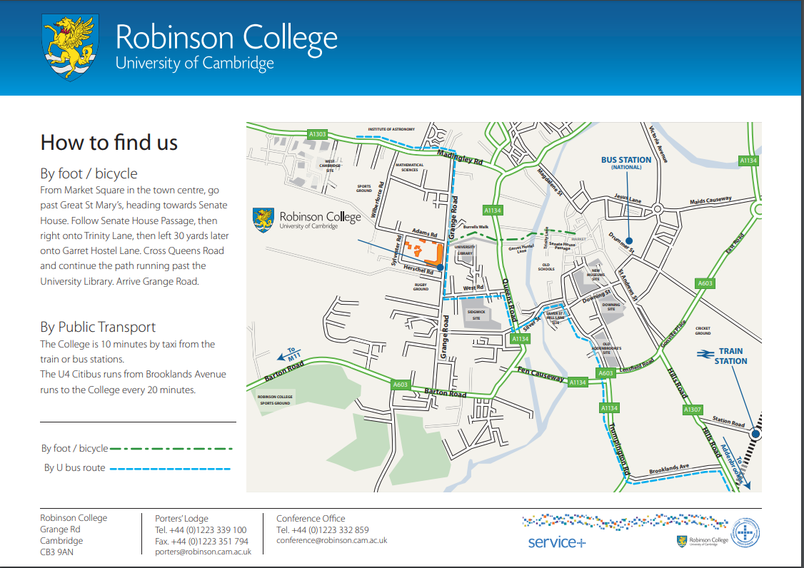

Annual General Meeting at Hilton Cambridge City Centre
20 Downing Street, Cambridge CB2 3DT

Cambridge Station
Station Road, Cambridge, CB1 2JW

Distance to AGM: 1.1 mile
Distance to Robinson College: 1.9 miles

National Express Coach Station: Cambridge City Centre
319 Parkside, Cambridge CB1 1PN

Distance to AGM: 0.5 mile
Distance to Robinson College: 1.2 miles

Grand Arcade Car Park
Corn Exchange Street, Cambridge, CV2 3QF
24-hour car park open Monday to Sunday

Distance to AGM venue: 0.2 miles
Distance to Robinson College: 0.8 miles

