REPORT ON AFRICAN SCHOOL OUTREACH HELD 7TH - 9TH JUNE 2023
Preamble
The International Veterinary Vaccinology Network (IVVN) is a non-profit organization aimed at increasing the participation and involvement of female secondary students in the field of sciences and scientific research. The overall aim is to encourage female students that the science field is not for males alone, but females can be scientists too and they can make great contributions in the field of sciences. Aside from this aim, the workshop will also help promote expert female scientists to serve as role models to the younger scientist and individuals with aspirations to become a scientist.
Train the Trainers program
The Outreach Program in Nigeria held between June 17th and June 22nd, 2023, marked an impactful and engaging initiative aimed at fostering scientific knowledge dissemination, community engagement, and skill-building within the region. This multifaceted event commenced with a dynamic refresher training on Saturday, June 17th, setting the tone for a week of meaningful interactions and knowledge-sharing. The opening day, June 17th, was a pivotal moment for the program as it commenced with an enlightening and inspiring refresher training session. The atmosphere was vibrant and enthusiastic as new volunteer scientists, brimming with a passion for scientific exploration and community empowerment, were warmly welcomed into the fold. These dedicated individuals were introduced to the core principles and objectives of the outreach program, setting the stage for an enriching experience.
The training session proved to be an essential foundation for the upcoming days, ensuring that all participants were well-prepared and aligned with the program's mission. During this session, the newcomers were acclimated to the program's ethos and were equipped with the necessary knowledge to make a meaningful impact during their interactions with local communities. Under the guidance of Dr. Funmilayo Afolayan, and the distinguished Dr. Esther Kanduma from the University of Nairobi, Kenya, the volunteers were exposed to a wealth of insights and practical tips. Dr. Afolayan's leadership and Dr. Kanduma's international perspective lent a unique and enriching dimension to the training, igniting a sense of global collaboration and mutual learning. The training was not limited to theoretical discussions; it also encompassed practical aspects. Volunteers were actively engaged in familiarizing themselves with the state-of-the-art equipment and materials essential for the outreach activities. This hands-on experience facilitated a seamless transition from training to implementation, ensuring that the volunteers were well-prepared to execute their roles effectively. This training workshop was held at the Cell Biology and Genetics Unit laboratory of the Department of Zoology, University of Ibadan, Ibadan on 17 June 2023.
These trainees, having completed the training served as facilitators during the school outreach program. A summary of researcher questionnaires completed before the training workshop showed that all the training participants (100%) are researchers and postgraduate students. On the question that asked for the level of public engagement, 16.67 % are novice and competent respectively while the remaining 66.67% are proficient. The researcher questionnaire completed after the training workshop showed that all the training participants responded that their level of public engagement is now satisfactory and that they will recommend a colleague to join IVVN African Schools Outreach Programme and that they will return to be part of another IVVN Schools outreach programme workshop. The summary of other responses is presented in Figures 1 and 2. Sample pictures taken during the training workshop are shown in Figure 3.

Figure 1: Bar chart representing scientists’ responses on the impact of the training.

Figure 2: Bar chart representing scientists’ responses on their experiences during the training workshop.
Report on the schools’ outreach
The official school outreach, a cornerstone of the broader program, commenced on Monday, June 19th, 2023, marking a pivotal moment of hands-on engagement, knowledge dissemination, and inspiration for both the visiting scientists and the eager students. The venue was Ojoo High School in Alaka, Ibadan, and the day began with a sense of purpose and enthusiasm as scientists gathered at the school premises as early as 7:00 am. Upon arrival, the school staff and students meticulously prepared a laboratory space, eagerly awaiting the start of the program. The lab suitcase, containing a treasure trove of scientific equipment and materials, was efficiently set up, ready to facilitate a day of exploration and learning. The stage was set for a day of transformative interactions that would shape the scientific aspirations of many young minds.
The morning unfolded with a vibrant school assembly, where the principal of Ojoo High School took the stage to introduce the esteemed scientists to an eagerly listening audience of students. This introduction served as a beacon of inspiration, illuminating the possibilities that lay ahead for the students and igniting a spark of curiosity within their hearts. The scientists, representing a diverse range of expertise and experience, took turns in introducing themselves to the students
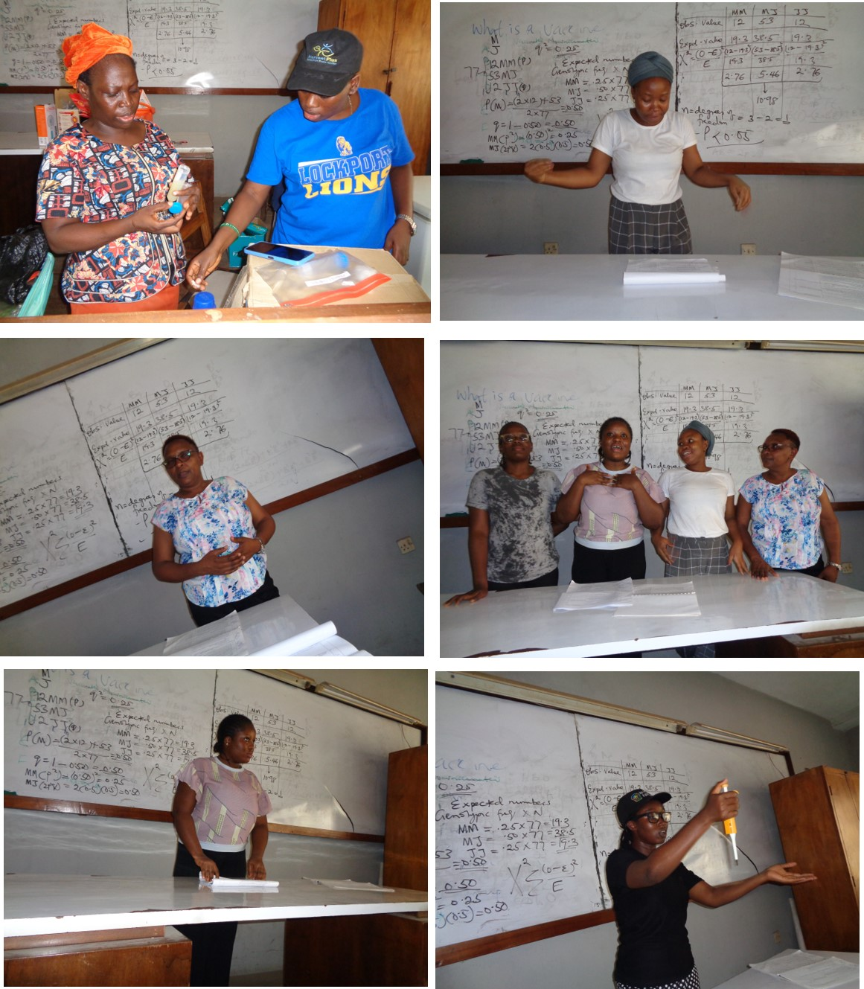
Figure 3: Representative picture during the training session for the Scientists

presents and shared the purpose and significance of their visit. In her heartfelt speeches, Dr Esther Kanduma emphasized the importance of remaining steadfast in their studies and nurturing a passion for science. Her words resonated deeply, planting seeds of aspiration and determination in the minds of the young audience.
The main laboratory activities kicked off immediately after the assembly, with 60 enthusiastic female students stepping into the lab for the first session. Guided by the scientists, and science teachers from the school, these students embarked on a journey of discovery, engaging in interactive experiments and practical demonstrations that brought scientific theories to life. The laboratory was alive with energy and excitement as the students delved into various aspects of the program, each scientist taking on the role of a mentor and guide. The same procedure was repeated during the afternoon session for another 60 female students.
Throughout the course of the day, a total of 120 students from Ojoo High School were immersed in this enriching experience, exposed to the wonders of science and the potential it held for their futures. As the clock approached 2:00 pm, the program drew to a close, but not before a heartwarming photo session captured the camaraderie between students, teachers, and scientists. Moreover, a meaningful tree-planting activity was conducted, symbolizing a commitment to environmental stewardship and climate change prevention.
The momentum of the outreach continued over the subsequent days, with the dedicated team of scientists venturing to Immanuel College in Ibadan on Tuesday, Community Grammar School in Mokola on Wednesday, and Baptist Academy, University of Ibadan on Thursday. While inclement weather on the last day hindered the customary assembly address at Baptist Academy, it did not deter the program's essence. The training laboratory remained abuzz with activity, as 143 students at Baptist Academy eagerly participated in the program's activities.
In summation, the four-day outreach program left an indelible mark, impacting a total of 503 students through intensive laboratory training and engaging approximately 2,000 students during the assembly sessions across the four visited schools. The students' resounding positive feedback and expressions of appreciation underscored the program's success in fostering curiosity and enthusiasm for science. Teachers were equally appreciative, recognizing the value of the hands-on experiments in enhancing students' understanding and future academic pursuits. The ripple effect of this program's profound impact promises to resonate through the corridors of these schools, shaping the trajectories of aspiring young scientists for years to come.
Summary of the student’s responses
Demographic overview: The workshop welcomed a diverse group of participants, comprising 503 individuals of varying ages. Their ages were distributed across a range, with the majority falling between 11 and 15 years old. Both gender was represented with 83.90% of the participants identifying themselves as females while 16.10% were males.
Feelings and impressions: Participants were invited to describe their sentiments about the workshop, yielding a multifaceted response. A substantial portion of attendees, 45.92%, found the workshop to be enjoyable and characterized it as "fun." Moreover, the workshop resonated as "informative" with nearly half of the participants (49.90%), indicating a valuable exchange of knowledge. The workshop succeeded in "inspiring" the majority (60.04%), while 65.81% found it "rewarding." The interactive and dynamic nature of the sessions also left a lasting impact, as many regarded the experience as "interesting" (81.91%) and "exciting" (74.95%). Additionally, a subset found the workshop to be "challenging" (20.28%) and "thought-provoking" (16.50%), indicating a depth of engagement.
Workshop enjoyment: The assessment of workshop enjoyment further underscores its positive impact. An overwhelming percentage, 83.70%, rated their enjoyment as "very good." This sentiment was substantiated by 12.33% who labelled it "good." A smaller portion of participants found the experience "satisfactory" (1.99%), while only a minor percentage rated it as "poor" (1.39%) or "very poor" (0.60%).
Alignment with workshop objectives: The participants' alignment with key workshop objectives and statements is noteworthy. An impressive 83.70% of participants agreed with the statement "All women can be Scientists," affirming their recognition of gender equality in the scientific domain. Furthermore, a significant percentage (83.50%) affirmed their knowledge about the use of vaccines to prevent infectious diseases from spreading. The workshop succeeded in fostering a sense of empowerment, with 63.42% expressing confidence that they could become scientists themselves. A remarkable 88.67% reported gaining insight into the protective role of vaccines for both animals and humans. The participants' dedication to sharing their experiences was evident, with 97.61% expressing an intent to communicate their workshop learning with their families.
Table 2: Socio-demographic characteristics and feelings of participants in the school outreach
Variable |  | Frequency | Percentage
 |  | (n = 503) | (%)
Age(years) | 9 | 1 | 0.20
 | 10 | 23 | 4.57
 | 11 | 68 | 13.52
 | 12 | 113 | 22.47
 | 13 | 114 | 22.66
 | 14 | 109 | 21.67
 | 15 | 47 | 9.34
 | 16 | 16 | 3.18
 | 17 | 11 | 2.19
 | 18 | 1 | 0.20
 | Male | 81 | 16.10
Gender | Female | 422 | 83.90
Words that best describe your feelings about your experience | Fun | 231 | 45.92
 | Boring | 16 | 3.18
 | Informative | 251 | 49.90
 | Inspiring | 302 | 60.04
 | Surprising | 42 | 8.35
 | Uninteresting | 4 | 0.80
 | Rewarding | 331 | 65.81
 | Interesting | 412 | 81.91
 | Confusing | 8 | 1.59
 | Enjoyable | 251 | 49.90
 | Challenging | 102 | 20.28
 | Thought-provoking | 83 | 16.50
 | Frustrating | 2 | 0.40
 | Dull | 0 | 0.00
 | Exciting | 377 | 74.95
How much did you enjoy the workshop? | Very good | 421 | 83.70
 | Good | 62 | 12.33
 | Satisfactory | 10 | 1.99
 | poor | 7 | 1.39
 | Very poor | 3 | 0.60
Do you agree with the following statement? | All women can be Scientist | 421 | 83.70
 | I know that vaccines are used to prevent infectious diseases spreading | 420 | 83.50
 | I could be a scientist | 319 | 63.42
 | I found out vaccines are used to protect animals and humans | 446 | 88.67
 | I am going to tell my family about the experience I had during this workshop | 491 | 97.61

Summary of the teacher’s responses
The engagement of participating teachers in the schools’ outreach program brought forth valuable insights and commendations that reflect the program's success and impact. Their observations not only underscore the positive influence of the outreach but also provide constructive suggestions for future improvements. The punctuality and overall organization of the researchers left a lasting impression on the participating teachers. Their appreciation for the well-structured and smoothly executed program speaks to the meticulous planning and dedication of the organizing team. This professionalism and attention to detail undoubtedly contributed to a conducive learning environment for both students and teachers alike.
A notable highlight mentioned by one teacher was the availability of high-quality equipment for students to engage with during the program. This factor not only heightened student interest but also enhanced the educational value of the outreach. The hands-on experience provided by these resources added an interactive dimension that enriched the learning process. Moreover, the teachers lauded the researchers' exemplary conduct during the training sessions. The researchers' organization, expertise, and demeanor resonated positively with the teachers, reinforcing the effectiveness of the program and the impact it had on all participants. This positive rapport between the researchers and teachers likely contributed to a conducive and collaborative learning atmosphere.
The teachers' unanimous interest in recommending the workshop to other schools is a testament to the perceived value and success of the outreach. Their eagerness to share this impactful experience with their peers reflects a belief in the potential of the schools’ outreach to benefit a wider educational community. Furthermore, the expressed desire for the outreach program to become an annual fixture in their schools underscores the enduring impact and sustained benefit the program has on both students and teachers. This continuity would facilitate ongoing engagement and skill development, contributing to the schools' educational objectives.
Considering the overall feedback of the teachers regarding the schools’ outreach, it becomes evident that the outreach program has the potential for even greater reach and effectiveness. Some teachers suggested expanding the program to include private-owned secondary schools, thereby widening its impact to a broader spectrum of students. The proposal to train science teachers who can subsequently train other students extends the program's influence and promotes a cascading effect of knowledge dissemination. Additionally, the idea of donating materials used in experiments to participate schools is a thoughtful suggestion. This gesture would not only reinforce the lessons learned during the outreach but also ensure that a larger number of students can benefit from the experience, even those who were not directly involved.
Lastly, the recommended timeframe for the outreach program, between July and November, aligns with the teachers' expectations and operational feasibility. This consideration would allow for optimal planning and execution, ensuring the program's effectiveness and maximizing participation. Other responses of the teachers are summarized in the bar charts below.

Figure 4: Bar chart showing the teachers’ responses on how they rated aspects of the workshop.

Figure 5: Bar chart showing the teachers responses on how successful the Outreach programme was in achieving the objectives of the workshop.

Figure 6: Bar chart showing the teachers responses on the impact of the workshop on the pupils.

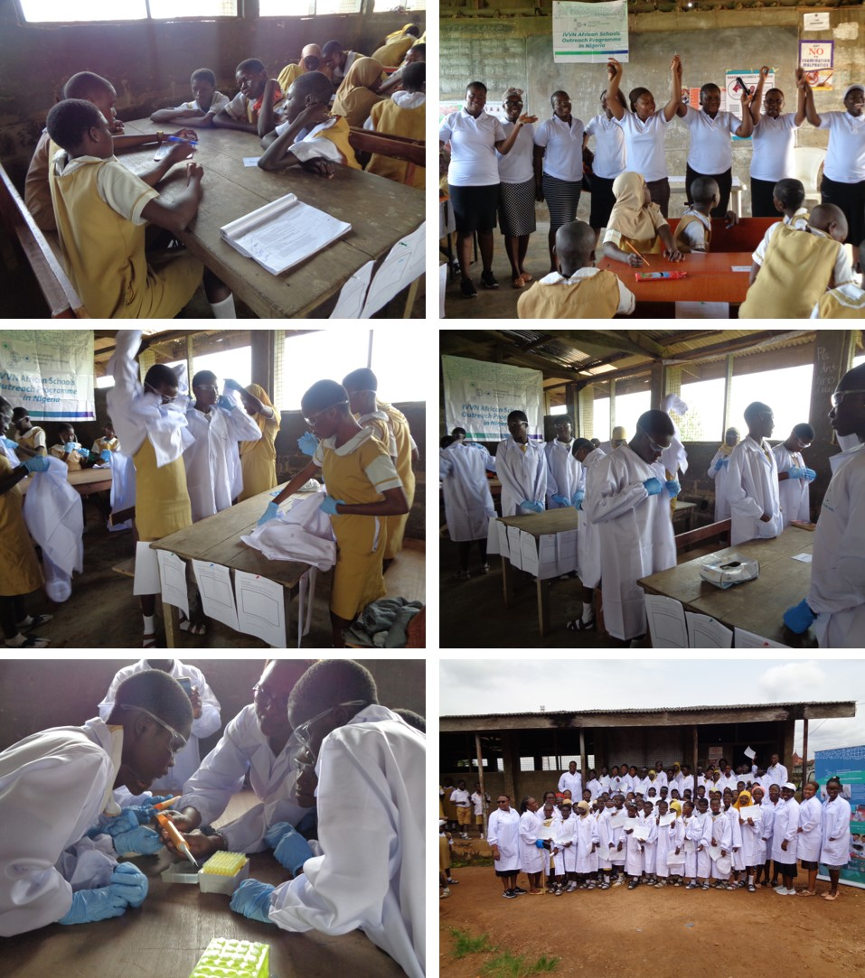
Figure 7: Representative of pictures taken during the school’s outreach programme at Ojoo High School, Alaka.

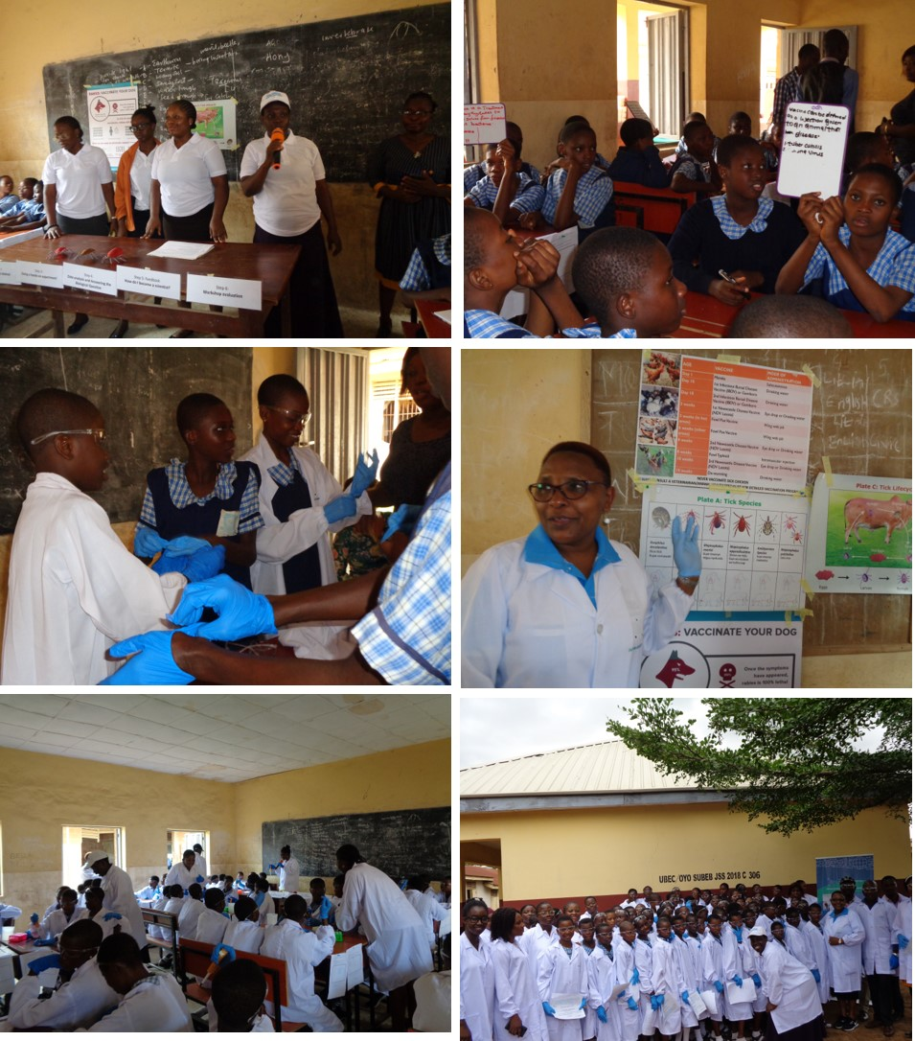
Figure 8: Representative of pictures taken during the schools outreach programme at Immanuel College, Orita University of Ibadab, Ibadan

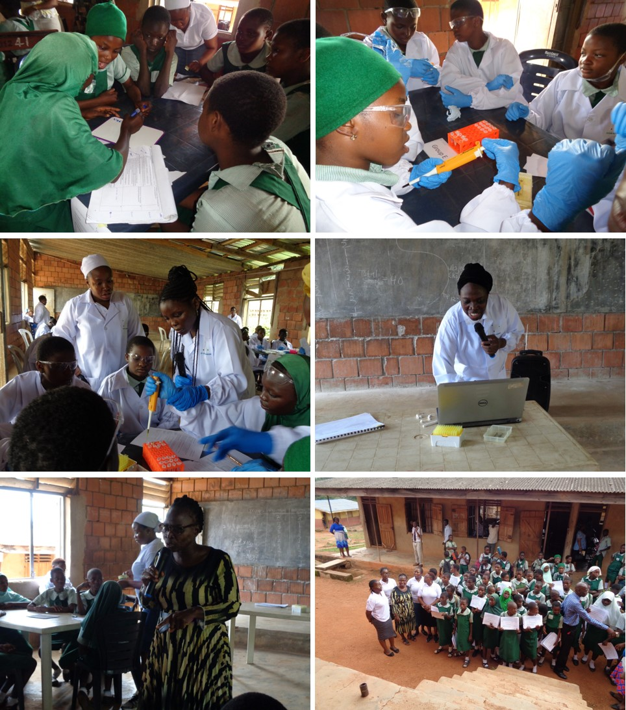
Figure 9: Representative of pictures taken during the school’s outreach programme at Community Grammar school, Mokola.

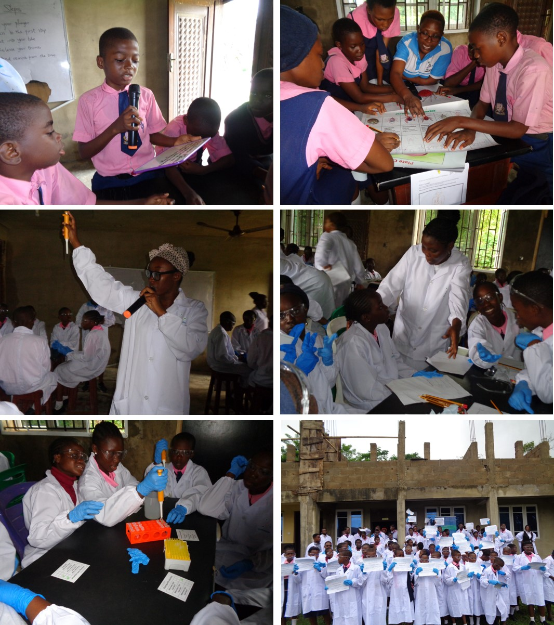
Figure 10: Representative of pictures taken during the school’s outreach programme at Baptist Academy, University of Ibadan.

https://photos.google.com/

